**IMSE 982 Final Project**

**Blake Conrad**

# Introduction

The objective of this project is to answer three very specific non-linear programming problems with a unique implementation of specified algorithms. The objective of this technical write up is to explain how conclusions were drawn for each of the problems. The three-part problem is listed below:

1. Solve a quasi-convex problem, illustrating from several different starting points the global optimal solution for each converges to the same point.
2. Solve a non-convex problem that has multiple KKT points, illustrating from several different starting points the local optimal solution for each converges to a different point.
3. Solve a quasi-convex problem with two or more constraints, illustrating the barrier function approaches feasibility and converges to the correct global optimal solution.

Tools used were the Python programming language utilizing Numpy, Pandas, and Matplotlib packages. Both Python files and IPython notebooks will be provided to illustrate each solution to the above listed problems. Algorithms implemented for these solutions included ***Golden Search*** (*Bazaraa, Sherali, Shetty p. 350)*, ***Conjugate Gradient Method*** – **Fletcher Reeves** (*Bazaraa, Sherali, Shetty p. 422-423),* and the ***Barrier Function Method***(*Bazaraa, Sherali, Shetty p. 469).*

We leverage our selected convex function defined in **Problem 1**,in **Problem 3,** with the addition of two constraints in order to illustrate the correct convergence point being approached via the barrier method. We now proceed to look at the functions selected, respective solutions, and details necessary to carefully articulate the solution.

# Problems Solved

## Problem 1

Quasi-convex function: Hyper-Bowl Function; $f:R^{3}→R$

$$f(x,y,z)=\left(x^{2}+y^{2}+x∙y\right)+\left(y^{2}+z^{2}+y∙z\right)+\left(x^{2}+z^{2}+x∙z\right)$$

$$∇f\left(x,y,z\right)=\begin{matrix}4x+y+z \\ 4y+x+z \\ 4z+x+y\end{matrix}$$

$$H\left(x,y,z\right)=\begin{matrix}4 & 1 & 1 \\ 1 & 4 & 1 \\ 1 & 1 & 4\end{matrix}$$

We select the function f displayed above. This function has many properties, and is indeed a hyper-bowl. *Illustration 1* shows an example of what this function looks like when a single dimension is held constant. The selected function for **Problem 1** is clearly convex, with a hessian that is strictly positive definite. Hence, we expect given several different starting points to see a unified point of convergence via the algorithm of choice. *Table 1* shows the output from the *Conjugate Gradient – Fletcher Reeves Method* using *Golden Search* on this function. As we can see, from 9 different randomly sampled points we converge on or very close to 0. With additional tolerance threshold $ε$ this value would surely converge to 0. We can also note how many iterations each took and the final x position denoted $X[N]$.

***Illustration 1****:* Image to articulate a 4-dimensional surface with a single dimension (z) held constant at 0.

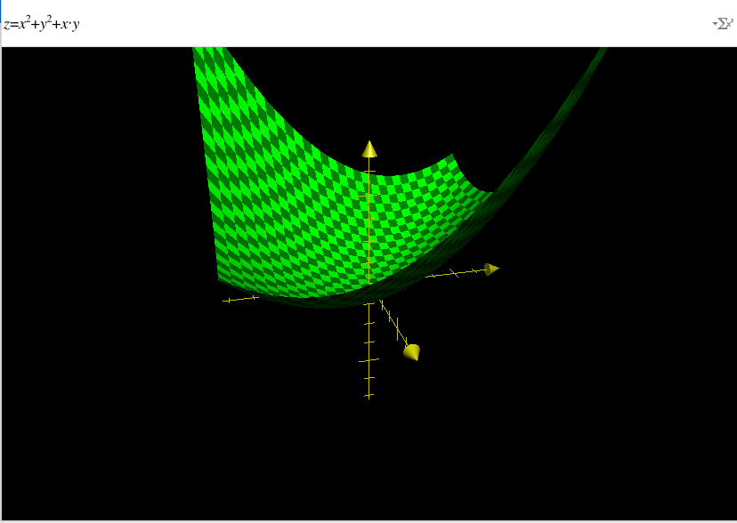

***Table 1****:* 10 Samples of Conjugate Gradient Fletcher Reeves Method converging to the same point (0,0,0), with different starting points.

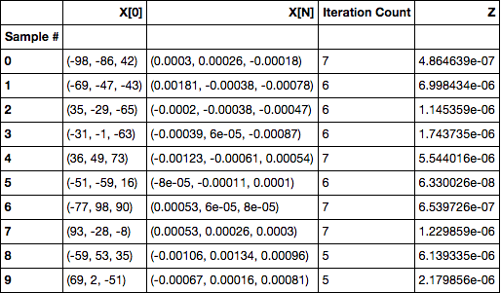

## Problem 2

Non Convex Function: Periodic Wave Function; $f:R^{3}→R$

$$f\left(x,y,z\right)=\sin\left(x\right)∙\cos\left(y\right)+\frac{y}{z}+\frac{x}{z}$$

$$∇f\left(x,y,z\right)=\begin{matrix}\cos\left(x\right)∙\cos\left(y\right)+\frac{1}{z} \\ -sin\left(y\right)∙\sin\left(x\right)+\frac{1}{z} \\ -\frac{x}{z^{2}}-\frac{y}{z^{2}}\end{matrix}$$

$$H\left(x,y,z\right)=\begin{matrix}-sin(x)∙cos⁡(y) & -sin⁡(y)∙cos⁡(x) & -\frac{1}{z^{2}} \\ -cos⁡(x)∙sin⁡(y) & -\cos\left(y\right)∙sin⁡(x) & -\frac{1}{z^{2}} \\ -\frac{1}{z^{2}} & -\frac{1}{z^{2}} & \frac{2x}{z^{3}}+\frac{2y}{z^{3}}\end{matrix}$$

We select the function f defined above. This function is known as a periodic wave function and provides us with the following properties:

1. Only convex in certain periodic regions, denoted in Appendix A.
2. Provides many, nearby, local peaks and valleys.

Both properties mentioned above give us the ability to know that provided several randomly sampled points, we would expect them to converge in differently locations, but also be relatively close. This is because of the wave like properties we have highlighted. So looking at *Illustration 2*, we can begin to visualize this 4-dimensional surface by holding the 3rd independent variable, z, constant. So we see the whirlpool like wave structure mentioned above. This property is true if we hold the x and y variables constant at 0 or 1 as well. After running the *Conjugate Gradient Method* with a *Golden Search* method to optimize step sizes each iteration, *Table 2* was produced. We can see similar to *Table 1*, our starting points in the $X[0]$ column and our final point once we converged at $X[N]$. We can see we started at very different initial locations and landed in different final locations with varying z-values. Hence, we have evidence to believe that our function is what we claim and that the non-convexity of it does not ensure that a local optimal is a global optimal.

***Illustration 2****:* Image to articulate a 4-dimensional surface with a single dimension (z) held constant at 1.

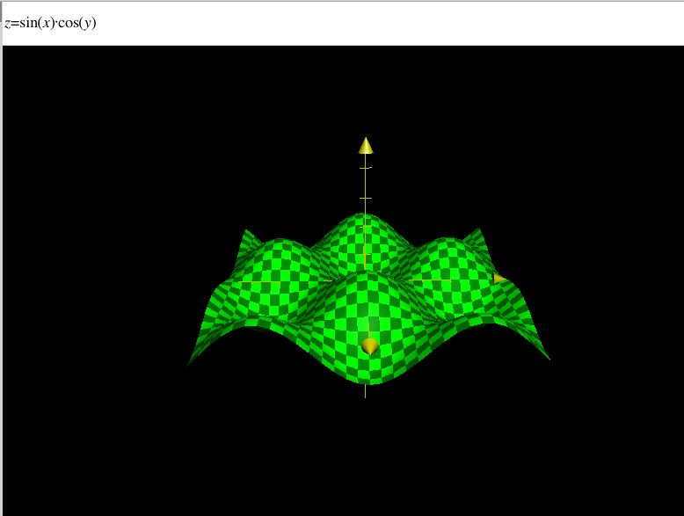

***Table 2***: 10 Samples of Conjugate Gradient Fletcher Reeves Method converging to different points with different starting points.

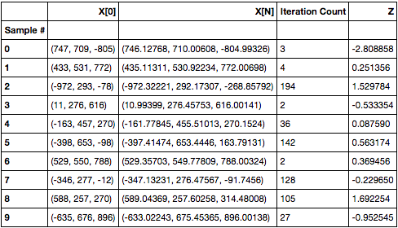

***Illustration 3****:* Display of each sample distant from one another with varying final points.

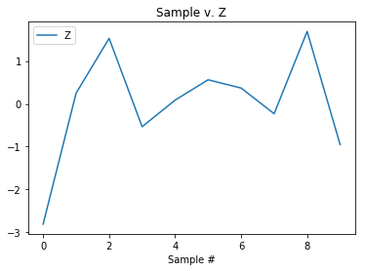

## Problem 3

Constrained Quasi-convex function: Hyper-Bowl Function; $f:R^{3}→R$

$$f(x,y,z)=\left(x^{2}+y^{2}+x∙y\right)+\left(y^{2}+z^{2}+y∙z\right)+\left(x^{2}+z^{2}+x∙z\right)$$

subject to:

$$g_{1}\left(x,y,z\right)=\left(x+y+z\right)≤1$$

$$g_{2}\left(x,y,z\right)=\left(x^{2}+y^{2}+z^{2}\right)≤1$$

The Barrier Function will be defined as

$$f\left(x,y,z\right)=\left(x^{2}+y^{2}+x∙y\right)+\left(y^{2}+z^{2}+y∙z\right)+\left(x^{2}+z^{2}+x∙z\right)+ μ[-\frac{1}{\left(x+y+z-1\right)}-\frac{1}{\left(x^{2}+y^{2}+z^{2}-1\right)}]]$$

The last function selected was identical to the first, providing properties of convexity as mentioned in problem 1. However, awd

* Paraboloid
* Inside of Hyper-sphere.
* Beneath Half-space.
* We expect only 1 KKT point for a convex function as illustrated in problem 1.
* We expect our solution at $\overline{x}=\left(0,0,0\right)$. Therefore, we expect under fletcher reeves conjugate gradient, $\lim_{μ→∞}{Min. f\left(x,y,z\right)=0}$.

***Table 3*:** Samples of Conjugate Gradient Fletcher Reeves Method converging to a single global optimal point as mu approaches 0.

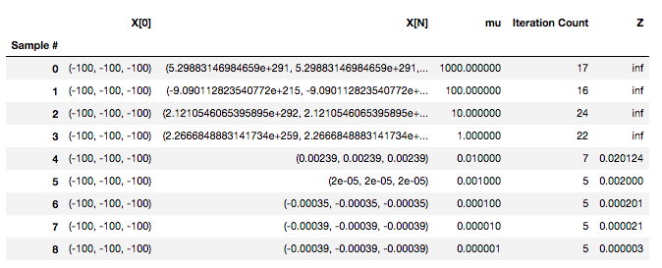

***Illustration 4:*** Display of barrier method converging to zero as the mu decreases exponentially.

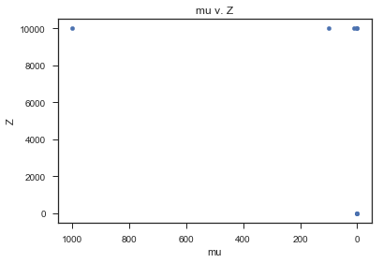

infinity

**Conclusion**

*References*

*Bazaraa, M., S., Sherali, D., H., Shetty, C., M. Nonlinear Programming Theory and Algorithms Third Edition*. *Wiley Publication 2006.*

*Appendix A*

Regions where $f\left(x,y,z\right)=\sin\left(x\right)∙\cos\left(y\right)+\frac{y}{z}+\frac{x}{z}$ is convex.

* + ||